Collection Framwork:
The Collection in Java is a framework that provides an architecture to store and manipulate the group of objects.
Java Collections can achieve all the operations that you perform on a data such as searching, sorting, insertion, manipulation, and deletion.
Java Collection means a single unit of objects. Java Collection framework provides many interfaces (Set, List, Queue, Deque) and classes (ArrayList, Vector, LinkedList, PriorityQueue, HashSet, LinkedHashSet, TreeSet).
A Collection represents a single unit of objects, a group.

What is Collection framework
The Collection framework represents a unified architecture for storing and manipulating a group of objects. It has:
- Interfaces and its implementations, i.e., classes
- Algorithm
What are the two ways to iterate the elements of a collection?
- What is the difference between ArrayList and LinkedList classes in collection framework?
- What is the difference between ArrayList and Vector classes in collection framework?
- What is the difference between HashSet and HashMap classes in collection framework?
- What is the difference between HashMap and Hashtable class?
- What is the difference between Iterator and Enumeration interface in collection framework?
- How can we sort the elements of an object? What is the difference between Comparable and Comparator interfaces?
- What does the hashcode() method?
- What is the difference between Java collection and Java collections?

Hierarchy of Collection Framework
Let us see the hierarchy of Collection framework. The java.util package
contains all the classes and interfaces for the Collection framework.
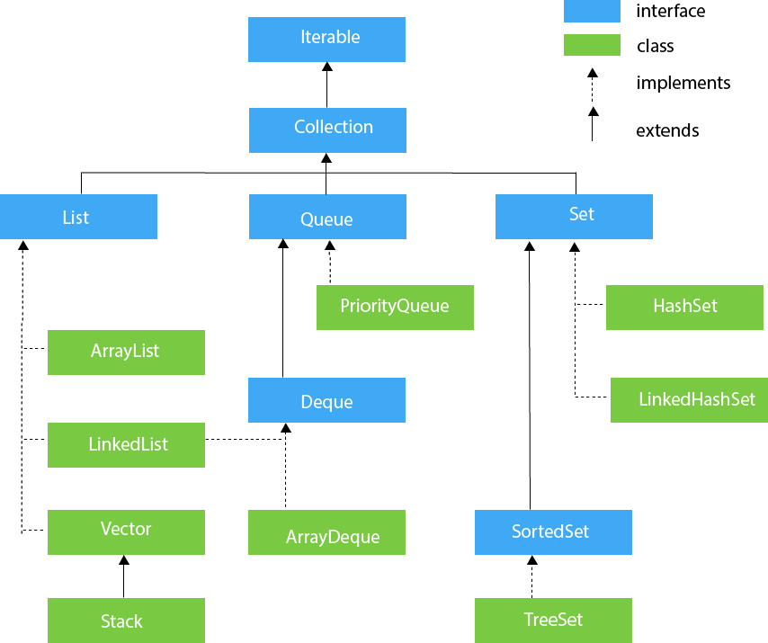

terator interface
Iterator interface provides the facility of iterating the elements in a forward direction only.

Methods of Iterator interface
There are only three methods in the Iterator interface. They are:
No. | Method | Description
1 | public boolean hasNext() | It returns true if the iterator has more elements otherwise it returns false.
2 | public Object next() | It returns the element and moves the cursor pointer to the next element.
3 | public void remove() | It removes the last elements returned by the iterator. It is less used.

Iterable Interface
The Iterable interface is the root interface for all the collection classes. The Collection interface extends the Iterable interface and therefore all the subclasses of Collection interface also implement the Iterable interface.
It contains only one abstract method. i.e.,

- Iterator<T> iterator()
It returns the iterator over the elements of type T.

Collection Interface
The Collection interface is the interface which is implemented by all the classes in the collection framework. It declares the methods that every collection will have. In other words, we can say that the Collection interface builds the foundation on which the collection framework depends.
Some of the methods of Collection interface are Boolean add ( Object obj), Boolean addAll ( Collection c), void clear(), etc. which are implemented by all the subclasses of Collection interface.

List Interface
List interface is the child interface of Collection interface. It inhibits a list type data structure in which we can store the ordered collection of objects. It can have duplicate values.
List interface is implemented by the classes ArrayList, LinkedList, Vector, and Stack.
To instantiate the List interface, we must use :
- List <data-type> list1= new ArrayList();
- List <data-type> list2 = new LinkedList();
- List <data-type> list3 = new Vector();
- List <data-type> list4 = new Stack();
There are various methods in List interface that can be used to insert, delete, and access the elements from the list.

The classes that implement the List interface are given below.

ArrayList
The ArrayList class implements the List interface. It uses a dynamic array to store the duplicate element of different data types. The ArrayList class maintains the insertion order and is non-synchronized. The elements stored in the ArrayList class can be randomly accessed. Consider the following example.
- import java.util.*;
- class TestJavaCollection1{
- public static void main(String args[]){
- ArrayList<String> list=new ArrayList<String>();//Creating arraylist
- list.add("Ravi");//Adding object in arraylist
- list.add("Vijay");
- list.add("Ravi");
- list.add("Ajay");
- //Traversing list through Iterator
- Iterator itr=list.iterator();
- while(itr.hasNext()){
- System.out.println(itr.next());
- }
- }
- }

Queue Interface
Queue interface maintains the first-in-first-out order. It can be defined as an ordered list that is used to hold the elements which are about to be processed. There are various classes like PriorityQueue, Deque, and ArrayDeque which implements the Queue interface.
Queue interface can be instantiated as:
- Queue<String> q1 = new PriorityQueue();
- Queue<String> q2 = new ArrayDeque();
There are various classes that implement the Queue interface, some of them are given below.

PriorityQueue
The PriorityQueue class implements the Queue interface. It holds the elements or objects which are to be processed by their priorities. PriorityQueue doesn't allow null values to be stored in the queue.

Deque Interface
Deque interface extends the Queue interface. In Deque, we can remove and add the elements from both the side. Deque stands for a double-ended queue which enables us to perform the operations at both the ends.
Deque can be instantiated as:
- Deque d = new ArrayDeque();

ArrayDeque
ArrayDeque class implements the Deque interface. It facilitates us to use the Deque. Unlike queue, we can add or delete the elements from both the ends.
ArrayDeque is faster than ArrayList and Stack and has no capacity restrictions.
Consider the following example.
- import java.util.*;
- public class TestJavaCollection6{
- public static void main(String[] args) {
- //Creating Deque and adding elements
- Deque<String> deque = new ArrayDeque<String>();
- deque.add("Gautam");
- deque.add("Karan");
- deque.add("Ajay");
- //Traversing elements
- for (String str : deque) {
- System.out.println(str);
- }
- }
- }

Set Interface
Set Interface in Java is present in java.util package. It extends the Collection interface. It represents the unordered set of elements which doesn't allow us to store the duplicate items. We can store at most one null value in Set. Set is implemented by HashSet, LinkedHashSet, and TreeSet.
Set can be instantiated as:
- Set<data-type> s1 = new HashSet<data-type>();
- Set<data-type> s2 = new LinkedHashSet<data-type>();
- Set<data-type> s3 = new TreeSet<data-type>();

HashSet
HashSet class implements Set Interface. It represents the collection that uses a hash table for storage. Hashing is used to store the elements in the HashSet. It contains unique items.

LinkedHashSet
LinkedHashSet class represents the LinkedList implementation of Set Interface. It extends the HashSet class and implements Set interface. Like HashSet, It also contains unique elements. It maintains the insertion order and permits null elements.

SortedSet Interface
SortedSet is the alternate of Set interface that provides a total ordering on its elements. The elements of the SortedSet are arranged in the increasing (ascending) order. The SortedSet provides the additional methods that inhibit the natural ordering of the elements.
The SortedSet can be instantiated as:
- SortedSet<data-type>set=new TreeSet();

TreeSet
Java TreeSet class implements the Set interface that uses a tree for storage. Like HashSet, TreeSet also contains unique elements. However, the access and retrieval time of TreeSet is quite fast. The elements in TreeSet stored in ascending order.
https://www.javatpoint.com/collections-in-java

Difference Between ArrayList and LinkedList
ArrayList and LinkedList both implement the List interface and maintain insertion order. Both are non-synchronized classes.
However, there are many differences between the ArrayList and LinkedList classes that are given below.
ArrayList | LinkedList
1) ArrayList internally uses a dynamic array to store the elements. | LinkedList internally uses a doubly linked list to store the elements.
2) Manipulation with ArrayList is slow because it internally uses an array. If any element is removed from the array, all the other elements are shifted in memory. | Manipulation with LinkedList is faster than ArrayList because it uses a doubly linked list, so no bit shifting is required in memory.
3) An ArrayList class can act as a list only because it implements List only. | LinkedList class can act as a list and queue both because it implements List and Deque interfaces.
4) ArrayList is better for storing and accessing data. | LinkedList is better for manipulating data.
5) The memory location for the elements of an ArrayList is contiguous. | The location for the elements of a linked list is not contagious.
6) Generally, when an ArrayList is initialized, a default capacity of 10 is assigned to the ArrayList. | There is no case of default capacity in a LinkedList. In LinkedList, an empty list is created when a LinkedList is initialized.
7) To be precise, an ArrayList is a resizable array. | LinkedList implements the doubly linked list of the list interface.

Difference between ArrayList and Vector
ArrayList and Vector both implements List interface and maintains insertion order.
However, there are many differences between ArrayList and Vector classes that are given below.
ArrayList | Vector
1) ArrayList is not synchronized. | Vector is synchronized.
2) ArrayList increments 50% of current array size if the number of elements exceeds from its capacity. | Vector increments 100% means doubles the array size if the total number of elements exceeds than its capacity.
3) ArrayList is not a legacy class. It is introduced in JDK 1.2. | Vector is a legacy class.
4) ArrayList is fast because it is non-synchronized. | Vector is slow because it is synchronized, i.e., in a multithreading environment, it holds the other threads in runnable or non-runnable state until current thread releases the lock of the object.
5) ArrayList uses the Iterator interface to traverse the elements. | A Vector can use the terator interface or Enumeration interface to traverse the elements.

Difference between HashSet and HashMap class in Java
The HashMap and HashSet in Java are the most popular Collection classes. Both are used for the data structure. The following table describes the difference between HashMap and HashSet:
Basis | HashMap | HashSet
Definition | Java HashMap is a hash table based implementation of Map interface. | HashSet is a Set. It creates a collection that uses a hash table for storage.
Implementation | HashMap implements Map, Cloneable, and Serializable interface es. | HashSet implements Set, Cloneable, Serializable, Iterable and Collection interfaces.
Stores | In HashMap we store a key-value pair. It maintains the mapping of key and value. | In HashSet, we store objects.
Duplicate values | It does not allow duplicate keys, but duplicate values are allowed. | It does not allow duplicate values.
Null values | It can contain a single null key and multiple null values. | It can contain a single null value.
Method of insertion | HashMap uses the put() method to add the elements in the HashMap. | HashSet uses the add() method to add elements in the HashSet.
Performance | HashMap is faster/ than HashSet because values are associated with a unique key. | HashSet is slower than HashMap because the member object is used for calculating hashcode value, which can be same for two objects.
The Number of objects | HashMap  There are two objects created during put operation, one for key and one for value.  Map | HashSet  Only one object is created during the add operation.  Set
Storing Mechanism | HashMap internally uses hashing to store objects. | HashSet internally uses a HashMap object to store objects.
Uses | It is used when we need to maintain the uniqueness of data. | Always prefer when we do not maintain the uniqueness.

Content: Iterator Vs Enumeration
- Comparison Chart
- Definition
- Key Differences
- Conclusion

Comparison Chart

BASIS FOR COMPARISON | ITERATOR | ENUMERATION
Basic | Iterator is a universal cursor as it is applicable for all the collection classes. | Enumeration is not a universal cursor as it applies only to legacy classes.
Access | Using Iterator you can read and remove the elements in the collection. | Using Enumeration you can only read the elements in the collection.
Methods | public boolean hasnext();  public objects next();  public void remove(); | public boolean hasMoreElements();  public object nextElement();
Limitation | Iterator is a unidirectional forward access cursor.  Iterator can not replace any element in the collection.  Iterator can not add any new element in the collection. | Enumeration is unidirectional forward access cursor.  Enumeration support only legacy classes.  Enumeration has only read-only access to the elements in a collection.
Overcome | To overcome the limitations of Iterator you must opt for ListIterator. | To overcome the limitations of Enumeration you must opt for Iterator.
Key Differences Between Iterator and Enumeration in Java
- The main difference between Iterator and Enumeration is that Iterator is a universal cursor, can be used for iterating any collection object. On the other hand, the Enumeration is used for traversing object of legacy class only.
- Enumeration object has only read-only access to the elements in the collection. However, the object of Iterator can read and remove the elements from the collection.
- There are two methods of iterator one to check the status of collection and one to retrieve the elements from the collection. In addition to Enumeration methods Iterator has one more method to remove the elements from the collection.
- Limitations of Enumeration are it is forward unidirectional cursor, it has read-only access, and it can be applied to the collection classes. On the other way, Iterator can not replace or add any new element in the collection and like Enumeration its also forward unidirectional cursor.
- Limitation of Enumeration are resolved by Iterator and limitations of Iterator are resolved by ListIterator.

Conclusion
Nowadays, Iterator and ListItertaor cursor are used as they are the universal cursor and are much efficient than Enumeration.

